Al-Anon Service Meeting Minutes
May 11th,2024
10 am-ELECTRONIC ONLY
Electronic sign in on AIS website

- Opening: Pat Serenity Prayer

- Reading of:
- 12 Traditions: Robin
- 12 Concepts of Service: Carol G
- Warranties: Terry D
- Expanded Concept of the Month: Diane

- Roll Call First Names Only
- See excel spreadsheet

- Welcome: Pat Welcome all to the AIS Rochester monthly meeting.
We hope you will find in this fellowship:
- Growth in your program and understanding of how AIS works.
- A welcoming environment where members feel safe and can express opinions and ideas freely, w/o interruption or criticism.
- Discussion and actions that benefit the Al-Anon groups in the Rochester area and beyond. (We welcome feedback, especially ideas for improvement).
- Contact information for Officers and AIS members, and an orientation for new members.
- Thank you for your service; rotation of service is important for our group’s health.

- Reports from Officers and Coordinators
- Chair: Pat H.
- Will be leading discussion on dual member as ISR

- Vice Chair: Open Position

- Secretary: Maggie
- Review of last month’s meeting minutes
- Motion to approve minutes : John F
- Seconded by: Marisa
- Minutes passed as written: Approved

- Treasurer: Diane: Reports attached at end of document

- AIS Treasurer report April 2024
- 2024 AIS Budget
- Transaction Report for April 2024
- Treasurer report approved as submitted.

Question from the group:
Q: Ellen asked if the Literature taken/used for outreach comes out of the outreach budget.
A: No, it does not
Follow up: Will be asking for Outreach to track/document what items they are taking from the office supply. Process will improve once new computer and software is purchased and processes established for items such as this one. More to come.

- Finance: Kathy M: Computer Quote attached at end of document
Tax Submission 2019
Met with a local IRS representative who could not help and sent us back to the Taxpayer Advocacy Service; consequently, the issues have not been resolved.

Book Depot Inventory Process (Cassandra P, Erin S, Terry D, Ellen V, Pat H, Kathy M)
Meeting held to understand the current process used for managing the AIS literature
Will be moving forward with QuickBooks inventory once the computer is ready

AIS Office Computer (Ellen V, Terry D, Kathy M)
While we were given approval last month to purchase a new computer, there was much work to be done before that could happen and the cost to replace the computer was higher than anticipated. There are still funds to cover the cost; the quotes are listed below ( end of minutes)
- Replacement of the computer was not included in the 2024 budget

Recommendation:
Even though LyteSpeed is slightly more expensive, the owner came to the office and looked at both the hardware and software requirements; spent 2 hours with us
Respectfully submitted,
Kathy M
AIS Finance Chair
_____________________________________________________________________
At the meeting, Kathy provided more information regarding the computer quotes. There was a question related to software costs. Specific amounts are unknown at this point. Group verbalized appreciation to Kathy and those that assisted in the research to identify best options moving forward.

John F motioned to move forward with recommendation to purchase at LyteSpeed
Harriet seconded the motion
Motion passed

- Book Depot: Cassandra P
Participated in meeting at AIS office regarding the current Book Depot ordering and inventory process. It would be nice to be able to track items not sold but used for an event, have the system keep track of book sales and ordering and adjust inventory accordingly. Discussed the ability to pay for literature by PayPal or credit card and keeping a QR code at literature tables during conventions and assemblies to enable people to buy literature if they do not have cash.
Terry and I reviewed the new filing system established for book orders. I plan to review the inventory we currently have in stock. Terry let me know about the stamps we have with our AIS Rochester contact information for the new pamphlets we bring in stock.
I downloaded the order history for the past two years for books ordered from the AFG website just to get an idea of what we have been ordering and how often.
Total sales at the Conference of the Lakes totaled $258.50. Some literature wasn’t recorded during the sales and at least one person paid by Paypal. I am looking into process improvements for events like these.
Highest selling literature at event:
- B-34- A Little Time For Myself
- P-24- Groups At Work
- B-16 Courage to Change
- P-16- To the Parents of Alcoholics
- P-24/27- Al-Anon/Alateen service manual
Please highlight this in our next newsletter as people can pay by PayPal or with Credit card when they purchase literature:
“Did you know you could pay by Credit Card or PayPal on the AIS Rochester website at https://www.aisrochester.org/donations/# by scrolling down and clicking on the PayPal button and following the page prompts?”
Respectfully submitted,
Cassandra P
_________________________________________________________________________
Following Cassandra sharing her report, there was input from Ellen V regarding info sheet for PayPal instructions for those wishing to purchase.
Ellen and Cassandra will meet to discuss our PayPal account set up and ways to optimize its use.

- Intergroup Rep: Loron
We are preparing for the Spring Assembly 5/18. Last night, we had a Meeting of AWSC- representing many groups comprising New York north. Topics we covered:
- Election of officers for NY north, we have candidate for Web Coordinator, we need a treasurer and Alateen coordinator.
- Thought force on opening the position of treasurer to members who have not been GR’s
- Tech thought force- will NYNorth accept electronic only meetings into our service structure?
WSO has asked us to make this decision by 2025 (?).
- Motions to save time at assemblies-read only highlights of minutes, rather than entire
document and have copies for review easily available.
- Consider having a GR/DR monthly meeting through NYNorth as a support for these members and get to know others in the position and share ideas and answer questions.
Spring Assembly 5/18-register on the NYNorth website-still time to do so.
Loron O. intergroup rep.

- Newsletter: Teresa
- Reports for newsletter due by: Wednesday May 15th

- Public Outreach: Dennis ( Loron filling in for Dennis)
We will meet this Wednesday at 4pm-Pls change time for this month only.
We are looking for members to join our group. Would AIS help us by sending Loron or Dennis lists of places you think and Al-Anon Flyer or tear off contact sheet may be helpful? We will create a master list of where we are supplying literature. Please send to outreach or put into chat.
Two libraries have asked for Al-Anon books to be donated for library users to check out. We have done this in the past. Will discuss at Wednesday meeting.
Thoughtful feedback on Al-Anon meetings every other week at Norris Clinic-this was set up as a lead into presenting at family groups at Norris. Family groups are not being planned currently. The Norris volunteers are discussing how to proceed -agree there is benefit-and we are not directly service our “target” audience. We have the Director of Norris to ask for their feedback on our presentations. Plan to be developed by next AIS meeting. Thanks to our great Norris Volunteers.
Rockcovery Fitness is having an Event in September. This is a road race and celebration of recovery. Last year service providers had displays. We will discuss Al-Anon being there.

- Volunteer/Office: Terry D
- Clean up of office started. Was able to discard some items and it is much cleaner which has improved the appearance of the office.
- Terry requested volunteers to cover the office phone messages Tuesday May 14th to Saturday the 18th. Cassandra, Ellen, and Maggie volunteered. Terry will reach out to them with details.

- Website: Ellen V
1. Please continue to send your events and committee meetings so I can put them on the events list
2. See web traffic information located at end of the minutes.
3. Working with Leah, our web tech, to update the email address of the officers and coordinators so messages they send out will not be from their personal email accounts, but with the AIS position.

Respectfully submitted,
Ellen V

- Alateen : Maureen: No report

- Activities : open position

- Group Announcements: see flyers on website events page
- Faith and Hope Anniversary Meeting Tues, May 14 at Noon
- Stepping Stones AFG 1st Anniversary Meeting Tuesday May 21st at 730
- Hamlin Sunday Niters 41st Anniversary Meeting Sunday June 9th 7pm

- Unfinished Business: Pat guided follow up discussion on topic below:
Can a dual member hold the position of ISR (Information Service Rep)?
Members asked to prepare for discussion by reading pages 59 & 87 in the current service manual.

Pat gave summary of the topic to group to bring those not at last month’s meeting.
Information shared today included what current AIS bylaws state, along WSO/Al-Anon service manual
- Page 87 from service manual:
“Al-Anon’s policy is that members who are also members of A.A. do not serve as Group Representative (GR), District Representative (DR), Area Delegate, World Service Conference member, alternate to any of these service positions, or on any committee of the World Service Office. “
“Filling service positions is a matter of District and Area autonomy within this policy and the spiritual principles that form its basis. Tradition Four grants autonomy to local service arms, except in matters affecting Al-Anon or A.A. as a whole. Al-Anon members who are also members of A.A. participate fully in all group activities, including group conscience decisions. However, they do not hold Al-Anon service positions that vote in matters affecting another group or Al-Anon or A.A. as a whole”.
- Although ISRs do participate in voting at the group and AIS levels, those votes do not affect Al-Anon as a whole and therefore do not go against our traditions.
- Note: If dual members hold ISR position, they cannot be the alternate GR.

Pat requested that this information be brought back to each of our home groups for discussion
prior to our June meeting.

- New Business: None
ATTACHMENTS:

Reports from Treasurer:

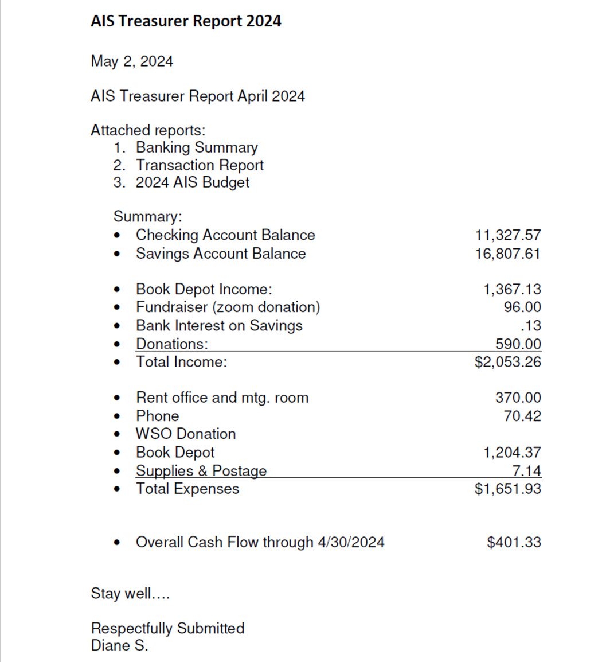

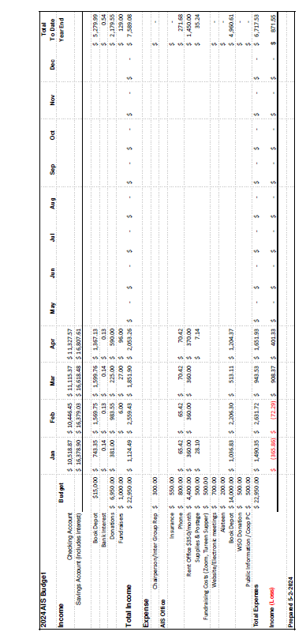
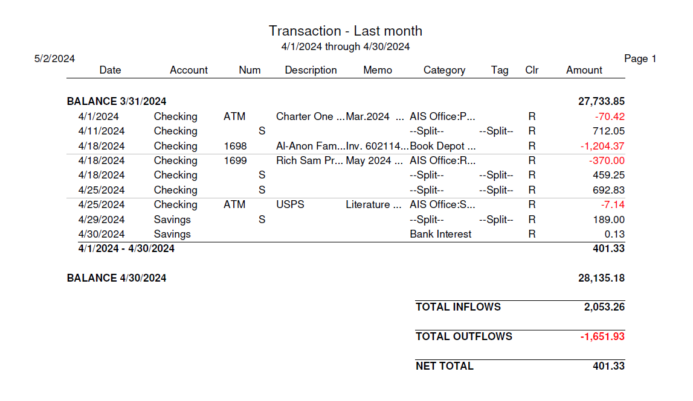

Attachment: Finance Computer Quotes

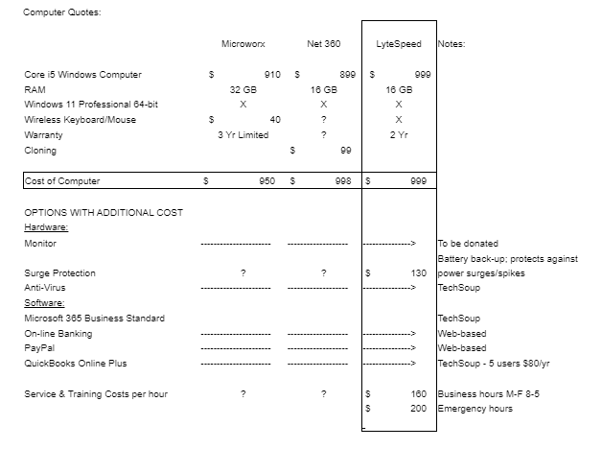

Attachments : Website Traffic Reports

